9th International Conference on Isotopes (9ICI) – the next global isotope highlight!

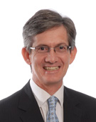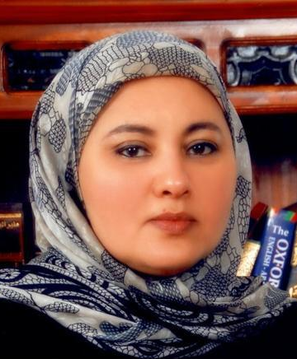

By Van Zyl de Villiers (President of WCI) &
Ilham Al-Qaradawi (General Chair of 9ICI)

We would like to remind World Council on Isotopes members and other isotope stakeholders that 9ICI is approaching fast! To be exact, this event of major importance will be held in the Marriot Marquis City Center Doha Hotel in Qatar from 12 to 16 November 2017.
In line with previous conferences in this successful series, 9ICI will consist of both a conference (with plenary sessions, parallel scientific/technical sessions, panel discussions and poster sessions) and an exhibition by suppliers and key isotope role-players. Topics to be covered include production processes and technologies, a variety of applications of radioactive and stable isotopes, security of supply, safety and transportation, policy issues as well as complementary matters. The International Medical Physics Day will also be celebrated, coinciding with Marie Curie’s 150th birthday.

A number of prominent leaders have already expressed support for 9ICI, including Drs Jong Kyung Kim (President, Korean Atomic Energy Research Institute), Andrew Klein (President, American Nuclear Society), William Magwood (Director General, Nuclear Energy Agency, Organization for Economic Co-operation and Development) and Dale Klein (Associate Vice-Chancellor, University of Texas System). Confirmed plenary speakers include Nigel Stevenson (Chief Operating Office, Clear Vascular, Inc.), Ramzi Jammal (Executive Vice-President, Canadian Nuclear Safety Commission), Simon Jerome (Head of Radiochemistry, National Physical Laboratory, UK), Meera Venkatesh (Director, Division of Physical and Chemical Sciences, IAEA) and Andreas Türler (Director, Laboratory of Radiochemistry, Paul Scherrer Institute, Switzerland).
The second call for papers will be issued very soon, with the abstract submissions deadline being 5 June. The early bird rate deadline is 20 July and the exhibition registration deadline is 1 August.
9ICI will provide a unique opportunity for researchers, isotope producers, isotope users, policy makers and the public to meet in a setting conducive to exchange views and information on topics of mutual interest. We are therefore looking forward to welcoming many 9ICI delegates and exhibitors in Doha in November!
Please see www.9ici.org for more information on the conference itself, instructions for authors, information for exhibitors and much more. You could obviously also use 9ICI as an opportunity to get acquainted with beautiful Doha and Qatar!

